**PREDICTIVE ANALYTICS LABORATORY**



**Submitted to**

**Ms.K.Vani**

**CURRENCY SWAP PREDICTION**

**REPORT**

**Submitted by**

**PRANAESH . R**

### COIMBATORE INSTITUTE OF TECHNOLOGY

### (A Government Aided Autonomous Institution Affiliated to Anna University)

### Coimbatore – 641 014,Tamil Nadu

**ABSTRACT:**

Our datset is about the prediction of the currency swaps using the factor analysis,principal component analysis and clustering such the kmeans clustering .and the dataset we used in this was the currecy exchange rate datasetfrom the yahoo finance.Currency exchange rates play a pivotal role in the global economy, influencing trade, investment, and financial flows across borders. This abstract provides a comprehensive overview of currency exchange rates, examining their significance, determinants, and dynamics.Firstly, the abstract outlines the importance of exchange rates in facilitating international trade and investment, serving as a mechanism for comparing the value of different currencies. Exchange rates impact businesses, consumers, and governments alike, influencing competitiveness, purchasing power, and economic policy decisions.Secondly, the abstract delves into the factors that influence exchange rate movements. These include macroeconomic fundamentals such as interest rates, inflation, and economic growth, as well as geopolitical events, market sentiment, and central bank policies.

**JAPAN DATASET:**

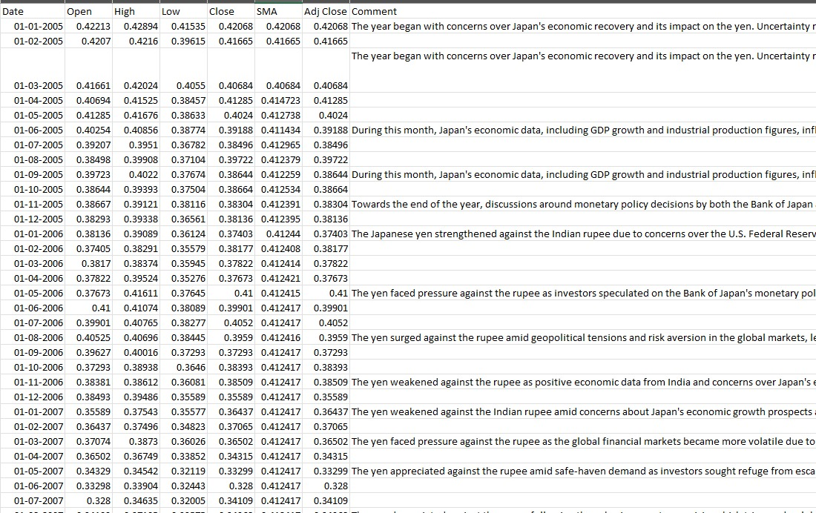

AUSTRALIA DATASET:

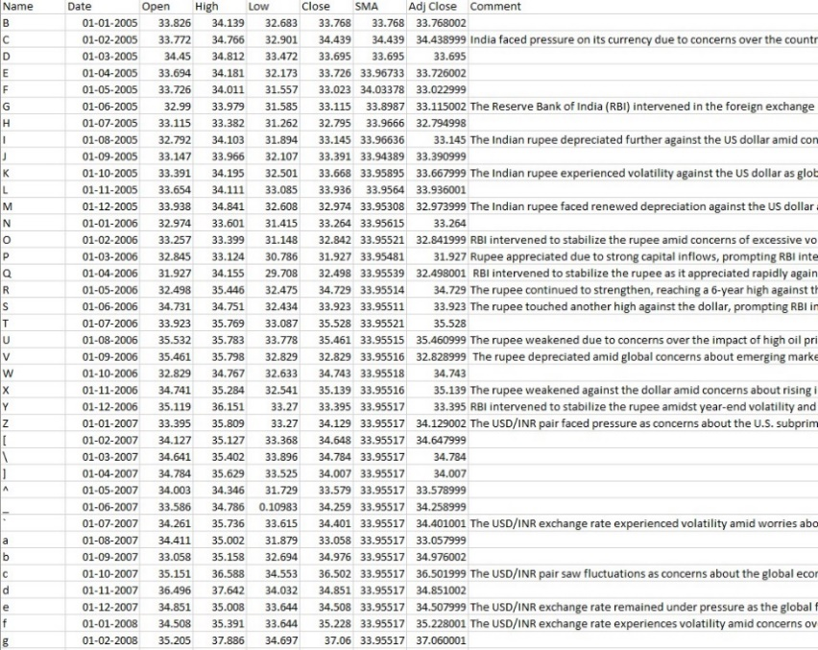

SWITZERLAND:

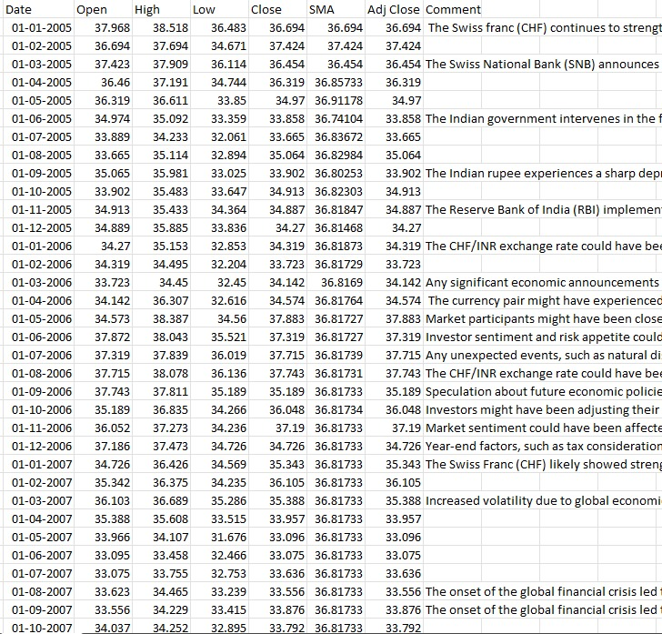

EUROPE:

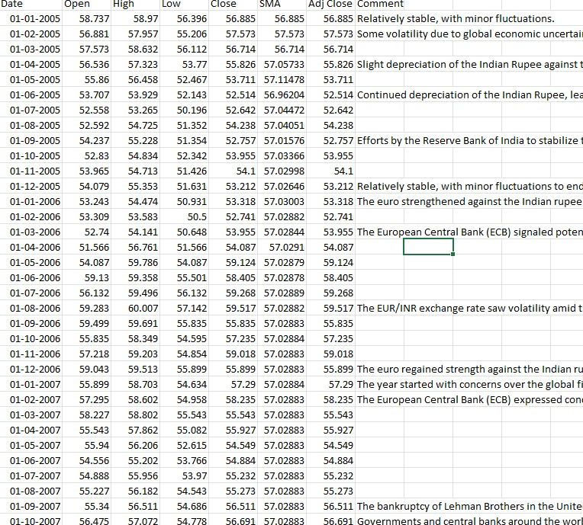

**CLUSTERING:**

**1)KMEANS CLUSTERING:**

K-means clustering is a popular unsupervised machine learning algorithm used for partitioning a dataset into a predetermined number of clusters. The goal of K-means clustering is to group similar data points together and discover underlying patterns or structures in the data.The algorithm works by iteratively assigning each data point to the nearest cluster centroid and then updating the centroids based on the mean of all points assigned to that cluster. This process continues until the centroids no longer change significantly, or a specified number of iterations is reached.The "K" in K-means refers to the number of clusters desired, which is specified by the user before running the algorithm. The algorithm aims to minimize the within-cluster variance, meaning it tries to make the data points within each cluster as similar as possible while keeping the clusters distinct from each other.K-means clustering is widely used in various applications such as customer segmentation, image compression, anomaly detection, and more, due to its simplicity, efficiency, and effectiveness in identifying clusters in high-dimensional data.

**MODEL USED IN KMEANS CLUSTERING:**

In K-means clustering for currency exchange rates, the model used is essentially the same as in any other application of K-means clustering. K-means clustering itself is model-agnostic, meaning it does not specify the type of model used for clustering.

However, in the context of currency exchange rates, the data points typically represent the exchange rates between different currency pairs over time. Each data point might consist of features such as the exchange rate between two currencies at a specific time or over a particular time period.

**Data Preparation**: Exchange rate data is collected and preprocessed. This may involve cleaning the data, handling missing values, and transforming the data into a format suitable for clustering.

**Feature Selection/Engineering**: Relevant features may be selected or engineered from the raw data. These features could include daily exchange rate changes, volatility measures, correlations between currency pairs, etc.

**Normalization/Standardization**: Since exchange rates may vary significantly in scale, it's often necessary to normalize or standardize the data to ensure that all features contribute equally to the distance calculations during clustering.

**Clustering**: The K-means algorithm is applied to the preprocessed and transformed data. The user specifies the desired number of clusters (K), often based on domain knowledge or through techniques like the elbow method or silhouette analysis.

**Interpretation**: After clustering, the centroids of each cluster represent the typical characteristics of the exchange rates within that cluster. Analysts can interpret these clusters to identify patterns or trends in currency movements.

**Evaluation (Optional)**:

Various metrics such as silhouette score or within-cluster sum of squares (WCSS) can be used to evaluate the quality of the clustering results. However, since K-means is an unsupervised learning algorithm, there's no ground truth against which to measure.A screenshot of a computer screen

**INFERENCE:**

**Feature Engineering**: Selecting relevant features like economic indicators or historical exchange rates.

**Clustering**: Identifying similar patterns in exchange rate data using techniques like K-means.

**Modeling**: Developing predictive models specific to each cluster, such as regression or time series forecasting.

**Evaluation**: Assessing model performance using metrics like mean absolute error.

**Continuous Improvement**: Iteratively refining models and strategies based on performance and market analysis.

Remember, predicting currency exchange rates is complex, and risk management is essential due to inherent uncertainty in financial markets.

**ANALYSIS:**

**1)PRINCIPAL COMPONENT ANALYSIS(PCA):**

Principal Component Analysis (PCA) is a technique used to reduce the dimensionality of high-dimensional data while preserving most of its variability. It identifies the directions (principal components) along which the data varies the most and projects the data onto these components. This allows for simplified data analysis and visualization while retaining important information.

**MODEL USED IN PRINCIPAL COMPONENT ANALYIS:**

Principal Component Analysis (PCA) itself is not a predictive model but rather a dimensionality reduction technique. However, PCA can be used as a preprocessing step in conjunction with predictive models for currency exchange rate prediction. Here's how it might fit into a modeling pipeline for predicting currency exchange rates:

**1)Data Collection and Preprocessing**: Gather historical data on currency exchange rates and preprocess it, which may involve cleaning, normalization, and feature engineering.

**2)PCA**: Apply PCA to the preprocessed data to reduce its dimensionality while retaining most of its variance. This step helps in identifying the most important features or patterns in the data.

**3)Model Selection**: Choose a predictive model suitable for currency exchange rate prediction. This could include regression models, time series forecasting models (such as ARIMA or LSTM), or machine learning algorithms like random forest or gradient boosting.

**4)Model Training**: Train the selected model on the PCA-transformed data. The reduced-dimensional data from PCA can potentially improve model performance by focusing on the most informative features and reducing overfitting.

**5)Evaluation and Validation**: Evaluate the trained model's performance using appropriate metrics and validation techniques such as cross-validation or train-test splits.

**6)Prediction**: Use the trained model to make predictions on new or unseen exchange rate data.

**7)Monitoring and Updating**: Continuously monitor model performance and update the model as new data becomes available to ensure its relevance and accuracy over time.

In this pipeline, PCA serves as a preprocessing step to reduce the dimensionality of the currency exchange rate data, making it more manageable and potentially improving the performance of predictive models by focusing on the most relevant information.

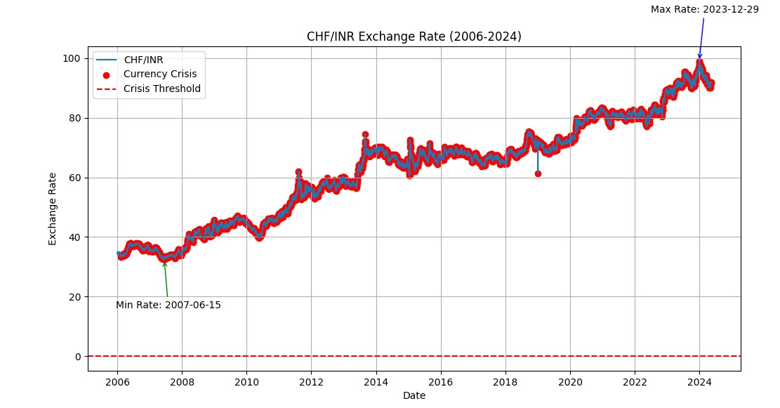

INFERENCE:

For currency exchange rates, Principal Component Analysis (PCA) can simplify the analysis of complex data by reducing its dimensionality while preserving important patterns. This streamlined data can then be used in predictive models to forecast exchange rate movements more accurately, aiding in decision-making processes related to trading, investment, and risk management.

**2)FACTOR ANALYSIS**

Factor Analysis is a statistical technique used to uncover the underlying structure of a set of variables. It is particularly useful when dealing with large datasets with many interrelated variables. The goal of Factor Analysis is to identify the latent factors or constructs that explain the patterns of correlations among observed variables.

**Data Collection**: Factor Analysis begins with the collection of data on multiple variables. These variables are typically chosen based on theoretical considerations or empirical observations, with the expectation that they are related to underlying constructs or dimensions.

**Correlation Matrix**: Once the data is collected, a correlation matrix is computed to examine the relationships between pairs of variables. The correlation matrix provides information about the strength and direction of the associations among the variables.

**Factor Extraction**: The next step is to extract the underlying factors from the correlation matrix. There are several methods for factor extraction, including principal component analysis (PCA) and maximum likelihood estimation. These methods aim to identify the factors that account for the most variance in the observed variables.

**Factor Rotation**: After the factors are extracted, they are often rotated to achieve a simpler and more interpretable structure. Rotation helps to clarify the relationships between the observed variables and the underlying factors, making it easier to interpret the results of the analysis.

**Interpretation**: Once the factors have been extracted and rotated, they are interpreted in terms of the variables that load onto each factor. Variables with high loadings on a particular factor are considered to be strongly associated with that factor, and the factors themselves are interpreted as underlying dimensions or constructs that explain the patterns of correlations among the observed variables.

**Factor Scores**: Finally, factor scores can be computed for each observation in the dataset. These scores represent the extent to which each observation is associated with each factor and can be used in subsequent analyses to examine the relationships between the factors and other variables of interest.

Factor Analysis is widely used in various fields, including psychology, sociology, education, and market research, to uncover hidden structures in complex datasets and gain insights into the underlying dimensions that influence observed variables.

**MODEL USED IN FACTOR ANALYSIS:**

Factor Analysis itself is not a predictive modeling technique but rather a method for uncovering underlying structures or patterns in data. However, Factor Analysis can be used as a preprocessing step in conjunction with predictive models for analyzing exchange rates.

**Data Collection**: Gather historical data on various factors that may influence exchange rates, such as economic indicators, geopolitical events, market sentiment, etc.

**Factor Identification**: Use Factor Analysis to identify underlying factors or latent constructs that explain the patterns of correlations among the collected data. These factors may represent broad economic trends, investor sentiment, or other relevant dimensions.

**Factor Rotation and Interpretation**: After extracting factors, rotate them to achieve a simpler and more interpretable structure. Interpret the factors in terms of the variables that load onto each factor, understanding their economic significance.

**Modeling**: Once the underlying factors are identified, use them as input features in predictive models for exchange rate forecasting. These models could include regression models, time series forecasting models, or machine learning algorithms.

**Evaluation**: Evaluate the performance of the predictive models using appropriate metrics such as mean absolute error (MAE) or mean squared error (MSE). Assess how well the models predict exchange rate movements based on the underlying factors identified through Factor Analysis.

By incorporating Factor Analysis into the modeling process, you can potentially improve the accuracy and interpretability of exchange rate predictions by capturing the underlying economic factors that drive exchange rate movements.

**INFERENCE:**

actor Analysis can enhance exchange rate prediction by identifying underlying economic factors that influence exchange rate movements. By uncovering these latent constructs, Factor Analysis enables the creation of more accurate predictive models, incorporating economic indicators, geopolitical events, and market sentiment. This approach allows for a deeper understanding of exchange rate dynamics and can lead to more informed decision-making in financial markets.

**FOREX:**

**GUI SCREESHOTS:**

